Sales Travel Request Approval

Author | Zari Salome
SE | Dennis Belavich
Version | 1.0

- Datasets
This workflow is included in the following datasets:

 | Ramsey WD |  | McGeever SWE
 | Ramsey WD (UK) |  | Nelson OneWorld
 | King AUS |  | Nelson OneWorld (AUS)
 | Huffman Manufacturing |  | Nelson OneWorld (UK)
 | Dilley PS |  | McGeever OneWorld SW/Services
 | Dilley PS (UK)

- Workflow Scenario
  - Sales Rep has create access for a Travel Request
  - Sales Rep Manager has add/edit access to a Travel Request approval
  - Controller has create/read/update access to Travel Request

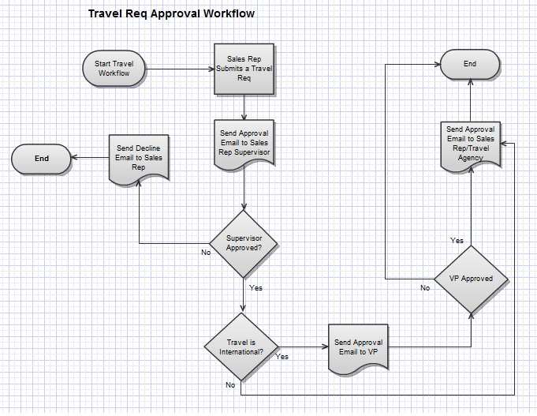
Note: VP in the image above has been replaced by Controller
- Assumptions
None

- Feature Dependencies
None

- Bundle Information
Install from TSTDRV658469.

- Dataset Setup Information
The ff. needs to be manually set-up in the dataset after installing the workflow bundle:

Employee Setup
    - Edit the Employee ‘Germany’ and change the name to ‘Jan Schumacher’.
    - Make sure the Employee ‘Clemens Fritz’ has Supervisor ‘Jan Schumacher’.
    - Edit the Employee ‘Ralph Schumacher’ and change the name to ‘Ralph Clausen’. Give it ‘Controller-EMEA’ access.
- Larry Nelson can’t be the Controller because the Workflow throws an error due to subsidiary issues. There will be 2 Controller – EMEA roles under the email main login.
- If a different Controller is needed (i.e. different Employee), that employee needs to be in the EMEA sub (i.e. if the Controller – EMEA looks at the Employee list, the name should be there). The ff. also needs to be changed:
  - Custom Record Type: Travel Request: Finance Approver field > Validation & Defaulting : Default Selection
  - Workflow: Travel Request Approval > Name of Controller field > Validation & Defaulting: Default Selection
Vendor Setup
    - Rename the Vendor ‘Habitat’ to ‘Thomas Cook’ and provide an email.
    - Rename the Vendor ‘TuxMobil’ to ‘American Express’ and provide an email.

Workflow Setup
    - Edit the field ‘Name of Controller’. Go to Validation & Defaulting tab and under Default Selection, choose ‘Ralph Clausen’.

Dashboard Setup
    - Add ‘My Travel Requests to Approve’ KPI to the Sales Manager – Germany and Controller – EMEA roles.

- Implementation Information
  - Travel Request
- Implemented as a Custom Record

  - CC Email
- The ff. needs to be changed in the Workflow if you wish to receive a copy of the email that is sent out. The CC field is found at the bottom of the page.
    - State: Entry > Action: Send Email
    - State: Pending Approval – Finance > Action: Send Email
    - State: Send Approval Email > 2 Actions: Send Email
    - State: Send Decline Email > Action: Send Email

- Demo Flow
- Using the Sales Rep – Germany (Clemens) role (Clemens Fritz)
  - Go to the Home dashboard.
  - Create a new Opportunity.
  - After saving the Opportunity, go to its Travel Requests tab and click on New Travel Request button.
  - In the Travel Request, ‘Travel Agency’ must be either ‘Thomas Cook’ or ‘American Express’ only.
  - Check ‘International Travel’ if you want to route approval to Controller.
  - An email will be sent to the supervisor’s email address with a link to open the record.
- Switch to the Sales Manager – Germany role (Jan Schumacher)
  - Go to the Home dashboard and click on ‘My Travel Requests to Approve’ KPI.
  - Review the request entered by the Sales Rep and click the Approve button.
  - The workflow will kick in and identify a requisition has be submitted, it will look up who submitted the request and auto generate an email to that Sales Rep’s Supervisor. The workflow request can either be approved or rejected by clicking on the appropriate buttons on the form.
  - Once approved, the workflow will continue to the next step in the process and determine if the travel request is an international travel request. If so, it will route the request to the next stage in the approval process, which is Controller approval. The Controller will repeat the secondary approval process which is the same steps taken by the previous Sales Manager. If it is not an international travel request then the travel agency is automatically notified via email of the appropriate travel approval and the workflow concludes.
- Switch to the Controller – EMEA role (Ralph Claussen)
  - Go to the Home dashboard and click on ‘My Travel Requests to Approve’ KPI.
  - Click on the Travel Request approved by the Sales Manager and click the Approve button.
  - The Travel Req workflow will send out a confirmation approval email to the travel agency.

- Limitations
None

- Possible Enhancements
None suggested

